CS 255 System Design Document Template

This template lays out all the different sections that you need to complete for Project Two. Each section has guidance to prompt your thinking. You will need to continually reference the interview transcript as you work to make sure that you are addressing your client’s needs. There is no required length for the final document. Instead the goal is to complete each section based on what your client’s needs are. Remove this note when you are finished, and replace all bracketed text with the relevant information.

UML Diagrams

UML Use Case Diagram

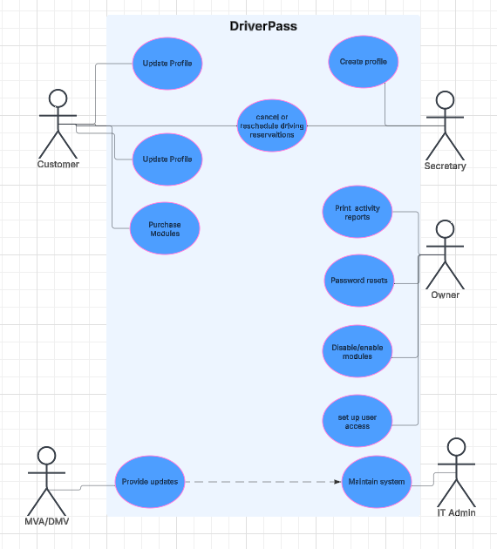

UML Activity Diagrams

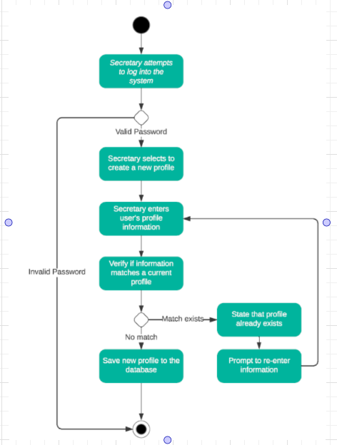

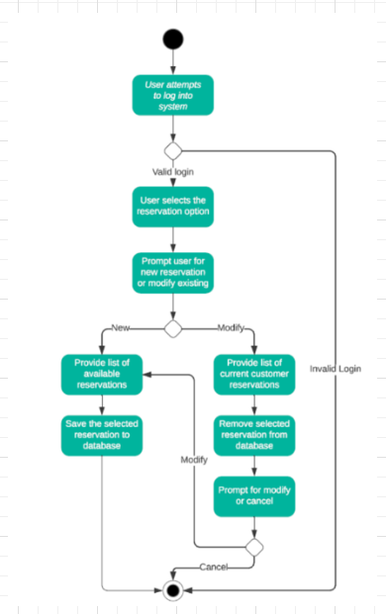

UML Sequence Diagram
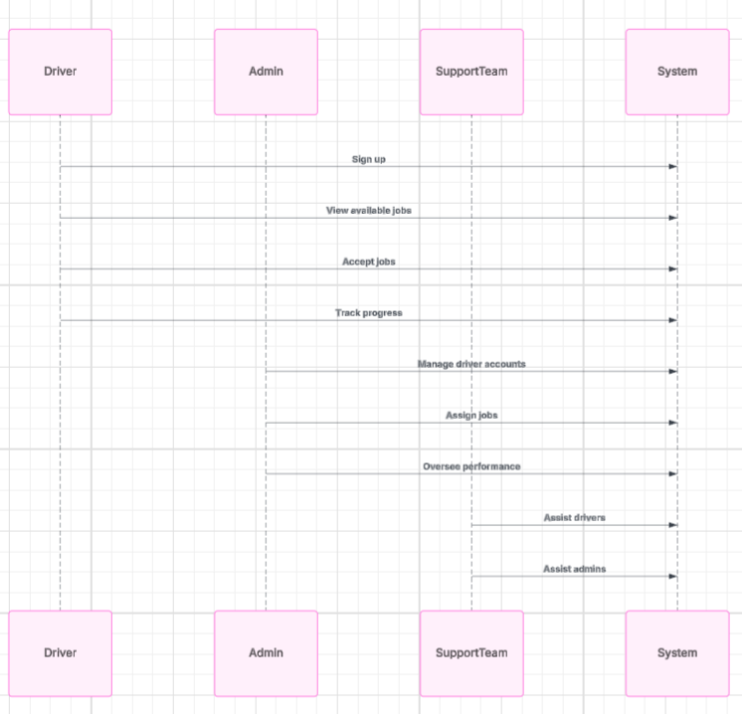

UML Class Diagram
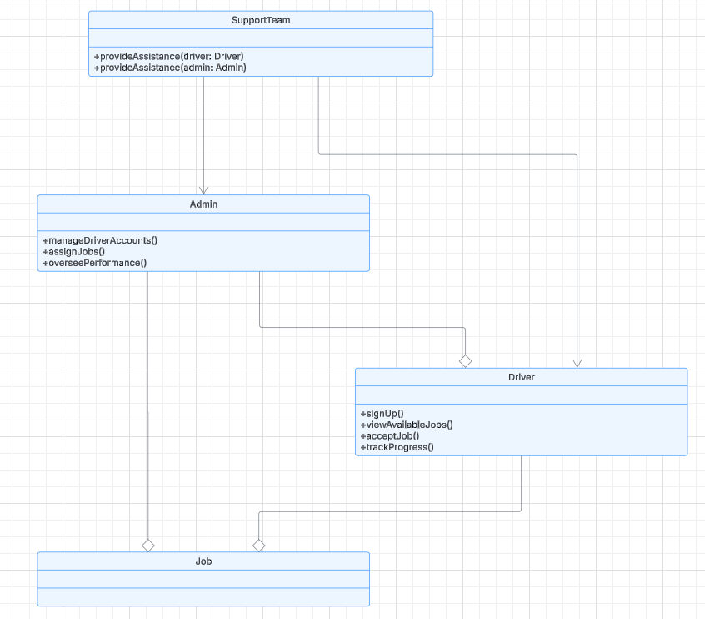

Technical Requirements
[Based on the diagrams you have created, describe the technical requirements of your system. These requirements should address the required hardware, software, tools, and infrastructure necessary for your system design.]

For the DriverPass system, we recommend deploying two separate web-hosted servers from a single provider to optimize performance and security. One server will host the publicly accessible website, where users can log in, while the second server will store all system data in a secure database that is only accessible from the first server. This architecture enhances security by limiting external access to the database. Both servers will run a Linux-based operating system (such as Ubuntu or CentOS) to minimize overhead costs and resource usage. Apache will be used for the web server application, and MySQL will handle the database, both of which are open-source solutions with no licensing fees. To ensure security, we will implement firewalls, SSL encryption, and access controls, restricting database access to the web server only. The infrastructure will be hosted on a reliable provider like AWS and we will incorporate regular backups, disaster recovery measures, and performance monitoring tools to ensure system resilience. Additionally, scalability options such as load balancing and auto-scaling will be in place to accommodate growth as user traffic increases.

